**HOW TO CHANGE IP ADDRESS ON LINUX**

**STEPS-**

Before changing your IP address, make sure to have a look at your current IP address.

To find your current IP address, you can use the “ip” command with the “a” option for address.

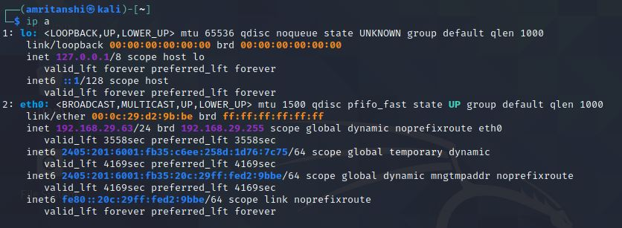

On modern distributions, the “ifconfig” command has been completely deprecated and it is now advised to use the “ip” command. However, you should still be able to use the “ifconfig” to change your IP address

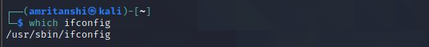

To change your IP address on Linux, use the “ifconfig” command followed by the name of your network interface and the new IP address to be changed on your computer. To assign the subnet mask, you can either add a “netmask” clause followed by the subnet mask or use the CIDR notation directly.



In order to verify that your IP address was correctly changed, you can run the “ifconfig” command followed by the name of your network adapter.

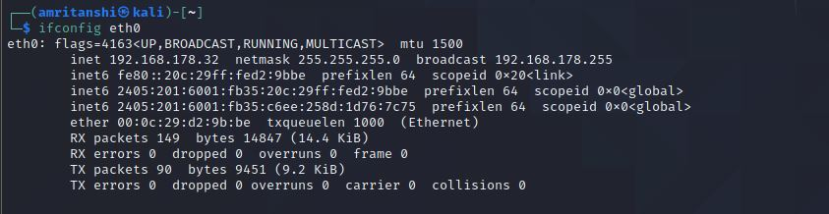

In order to change your IP address on Linux, you will have to add your network configuration in the “/etc/network/interfaces” or create this file if it does not exist already.



# Content of /etc/network/interfaces

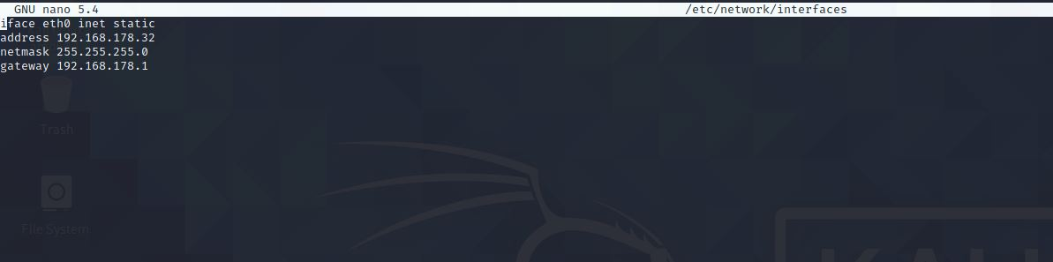

In order for the changes to be applied, you will need to restart your networking service (managed by ifupdown)

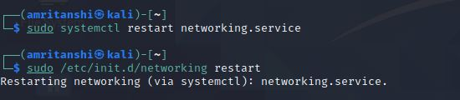

After restarting your networking service, you should be able to see your new IP by running the “ifconfig” or the “ip” command.

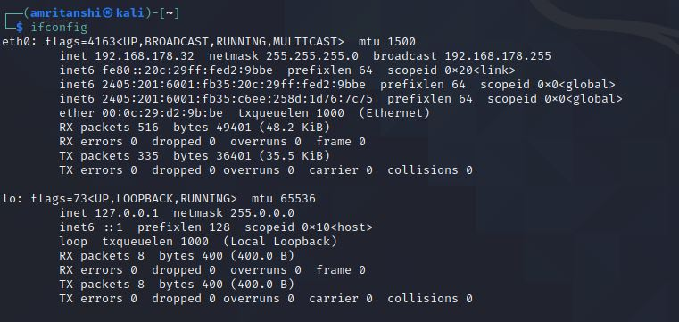

**Modify IP Address using Graphical Interface**

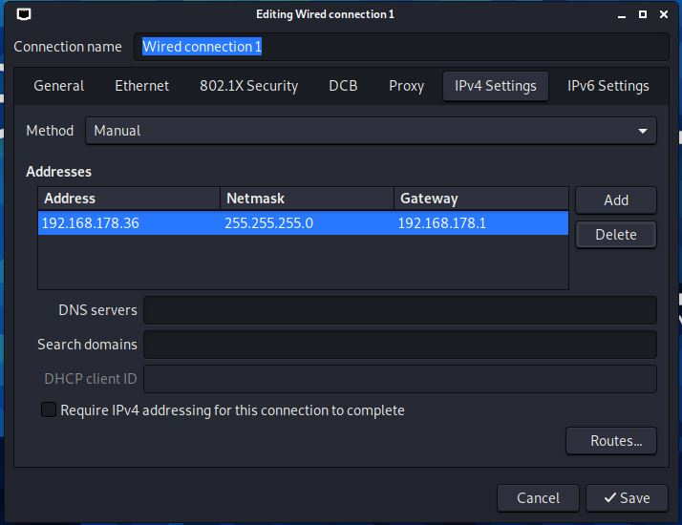

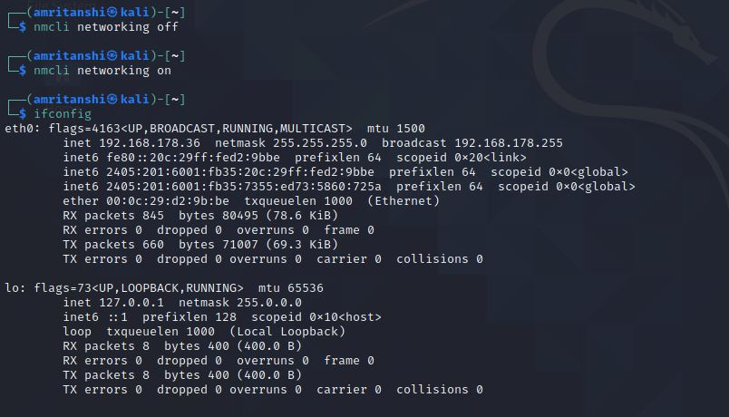

----------x---------------------x---------------------x---------------------x-----------------------x---------